# Kvar från sem 2

1. (For grades 4&5) Consider how you can integrate and use a software ecosystem in your business model, and if and how you potentially could benefit from this. See project **task 8**.
2. Initiate prototyping of your solution, see project assignment task 5, with the aim of:
   1. concretizing your solution idea, internally within group
   2. for grade 5, assessing your **product-market fit**(testning) by using a very simple prototype (paper or mockup) with potential customers or users

# Entry tasks & questions (before seminar)

1. For your course project, identify the requirements for the solution
   1. Consider **what use cases and features the software should support**?
      1. **Schemaläggning**
      2. **Utskick**
      3. **Fakturahantering - integration med andra plattformar**
      4. (App - Närvaro)
      5. **Kommunikation mellan deltagare**
      6. Evenemang/Tävlingar
      7. **Godkänna nya medlemmar**
      8. **Statistik över medlemmar**
   2. Produce an initial **VERY simple prototype** of your solution, see project task 5. - Fanny och Sabah
   3. Consider which quality aspects and levels that are important, e.g. regarding performance, security, capacity for number of simultaneous users etc.
      1. Datasäkerhet (BANK ID, (Freja eID), medlemsregister och fakturahantering)
      2. Användarvänlig - enkelt och smidigt (även för icke teknisk kunniga)
      3. Prestanda - overall (inte lagga, user friendly, snabb responstid)
   4. Consider possible limitations with implementing the requirements.
      1. Tid
      2. Utgångs-kapital
      3. Rykte
      4. OSS - GPL license
      5. (GDPR)
2. Ghazi et al. discuss success factors in software projects (Tables 1 and 2, respectively)– and claim that technology plays less of a role than management when it comes to projects. Does this imply that technology is unimportant in relation to the other factors?
   1. No, but that it doesn’t play a big a role as management when it comes to software project success. Tom also says “As we add new technological tools to our development process, our work becomes less, not more, technological in its focus.”
3. What is the difference between a system anatomy and a project anatomy?
   1. They are a **tool for integration planning** that visualises dependencies between work items in development projects. Project anatomy använder samma struktur som system för den är en variant men använder sig av shipments istället(fungerar som olika lager eller hierarkier).

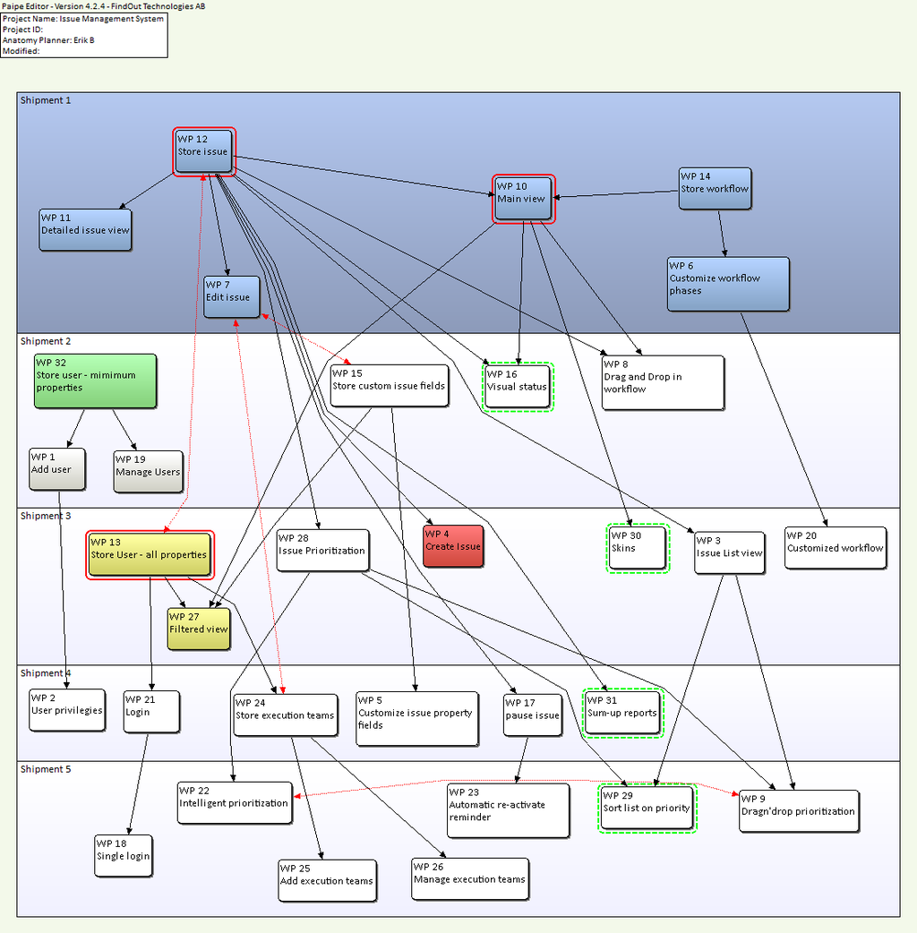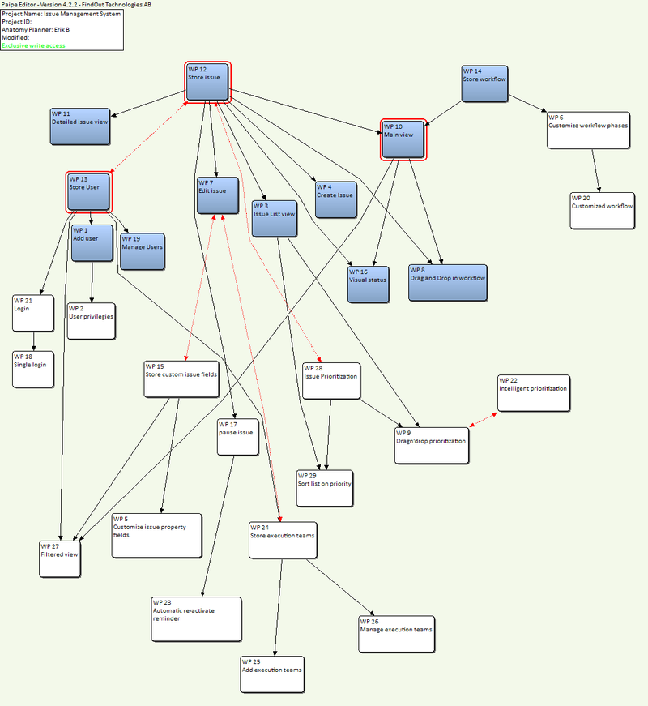

# Tasks at the seminar

### Produce an initial plan

1. Create a system anatomy, see Subtask 7a, by holding an anatomy day workshop.
2. Identify the activities to include in your implementation plan, see Subtask 7b.
3. Estimate effort and type of resources needed for each activity, see Subtasks 7c and d.
4. Produce your implementation plan including milestones, see Subtask 7e.

# Project assignment: Next steps

1. Perform risk management by identifying, analyzing, and prioritizing risk, see project task 8
2. For grades 4 &5,a.Use prototyping to validate product-market fit, see project task 5.b.Perform a market analysis using SWOT, see project task 9.
3. Update your report and submit Draft 2, see project task 10.